# CS 340 README Template

## About the Project/Project Title

*Rescue Animal Training Database and Web-Application*

Creating a database that will use existing unstructured data from multiple animal shelters in the region that can interface with a client-facing web application dashboard.

## Motivation

The database and application will facilitate searching existing unstructured data for the best animals to train for various rescue needs/situations. Users will need to be able to search fields such as animal age, breed, sex, and location to find the best matches for the training programs. They will need to update these animals to correct information or reflect changes. Users will also need to delete animals if they were entered in error or after the desired amount of time has passed since adoption or death to keep database storage as low as possible while still maintaining relevant records.

The customer provided search requirements for animals to train for specific rescue types. Users need to be able to easily search for animals that meet these requirements as such these filters will be set for users to access with an easy dropdown. The dashboard will adapt to user input and display a selected animal on a map. A visual representation of the animals that meet the selected requirements will be displayed as well as a map that displays the location of any selected animal. These features will improve useability for the customer.

## Getting Started

## The following steps will guide you through the process of creating a local copy.

## Using the Linux terminal import the database to your Mongo environment using the following command (substitute variables as needed for your environment).

mongoimport --username=${MONGO_USER} --password=${MONGO_PASS} --host=${MONGO_HOST} --port=${MONGO_PORT} /usr/local/datasets/aac_shelter_outcomes.csv --type csv --db AAC --collection animals --authenticationDatabase admin –headerline

Successful example below. 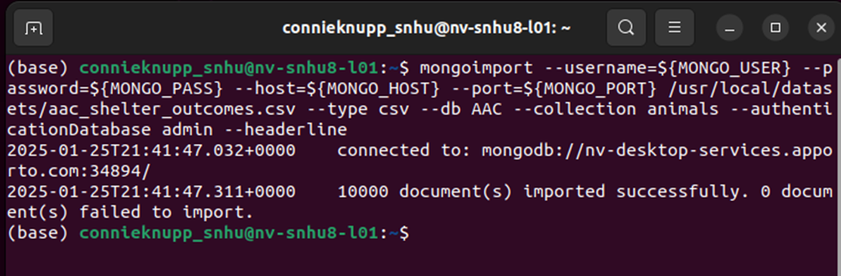

1. Launch the mongo shell and create indexes based on fields the users will likely need to search as demonstrated below. This will speed querying down the road.

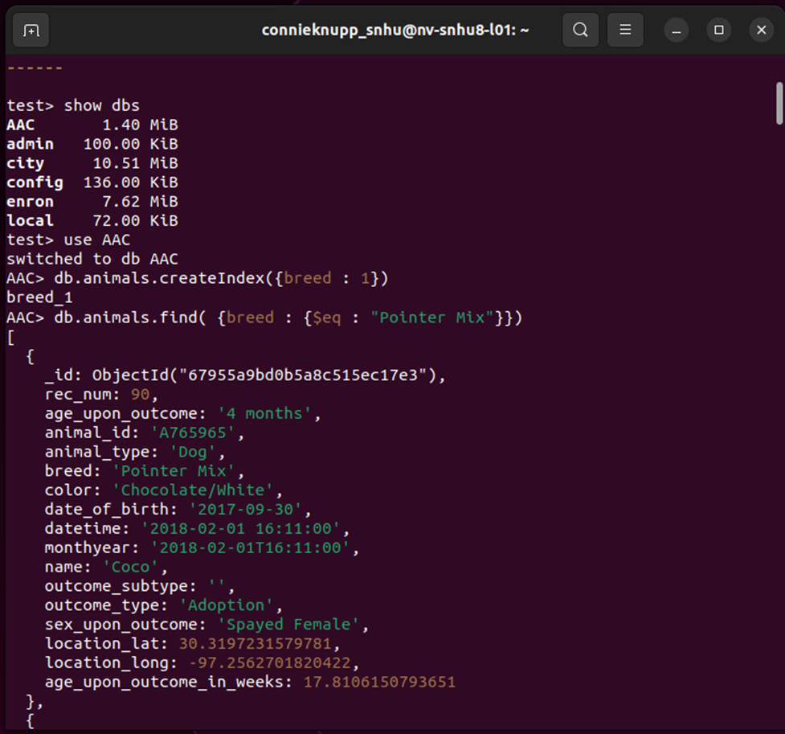

1. In the mongo shell switch to the admin or authentication database and create an admin role as well as an account user role. Account users should be restricted to read and write access as demonstrated below.

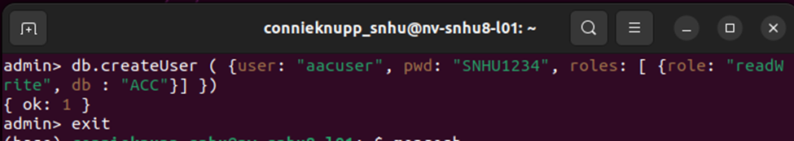

1. Download the files CRUD_pythonMod.py, ProjectTwoDashboardCknupp.ipynb, testingScriptMod5.ipynb, and the assets folder containing Grazioso Salvare Logo.png into the same project folder accessible by Jupyter. To test the Crud functionality, Launch Jupyter open the testingScripts file and run through the testing scripts.
2. To launch and test the dashboard open ProjectTwoDashboardCKnupp on Jupyter and run the cell. Click on the link under the run cell or navigate to an internet browser and put 127.0.0.1:27593 in the address bar. You should be able select a drop-down, filter and sort the columns, and select animals to display in the map.

**Installation**

* Linux Terminal or windows command prompt.
* MongoDB
* Jupyter
* Optional: Pycharm or preferred alternative IDE for making changes with Python files.

## Usage

The CRUD python module (CRUD_pythonMod.py) can accomplish basic CRUD tasks on the NoSQL database using methods and functions created. The Python library, Pymongo was used to create this layer in the system as it allows the python class to interface with the MongoDB. Python is a versatile language that will interface easily with both the database and the web-based client application that is coming. CRUD functionality includes: creating entries, reading/searching entries, updating entries and deleting entries. These functions are necessary core functions for maintaining and accessing information in a database. The Dash framework was used via Jupyter_dash to create the dashboard application as it works will with plotly express, numpy and pandas to interpret data and create visual representation of the results. Utilizing these open sourced and well-known modules makes the dashboard visually pleasing, easy to learn and intuitive for users. Dash uses wrappers to pass text, items, images, charts, etc to the webpage and allows for dynamic resizing so the application runs on many devices. This is a well established framework that is very adaptable as one gains experience using it.

### Code Example

### CRUD Functions (Completed on prior release, to view Dashboard Code please go to page 5).Create Method to add animals to the database.

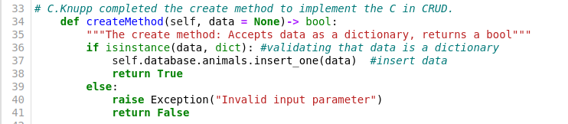

Read Method to search with the database for animals that meet specific search criteria.

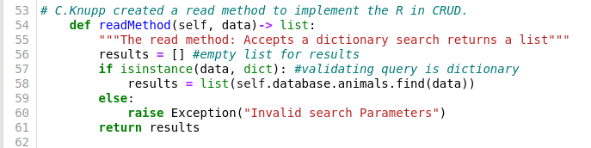

Update Methods to search for and update specific animals in the database.

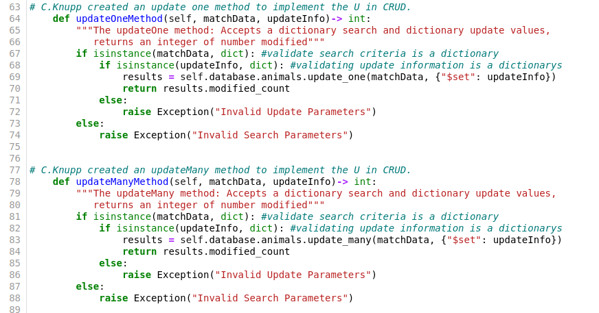

Delete Methods to search for and delete specific animals in the database.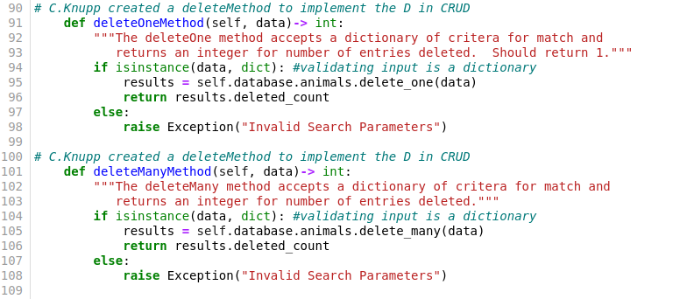

**Dashboard Code**

Logo with identifier

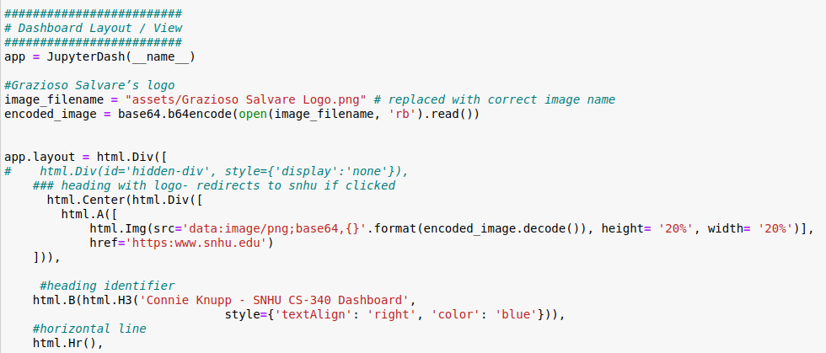

Drop-down filters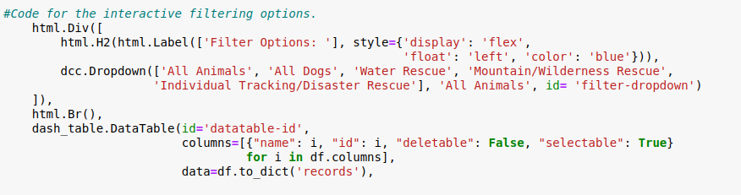

Data table with sortable and filterable columns, also single selectable rows. 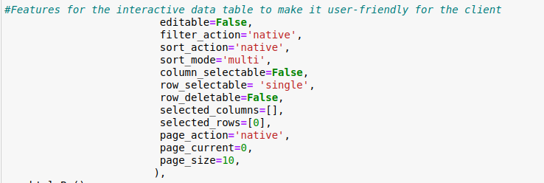

Application layout for pie chart and map with bar graph under it. 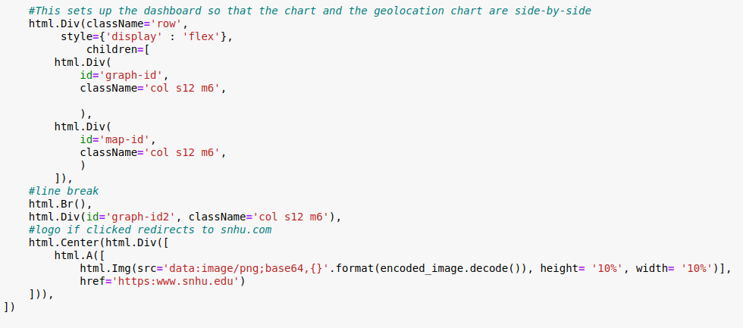

Callback for updating filters based on drop-down selection

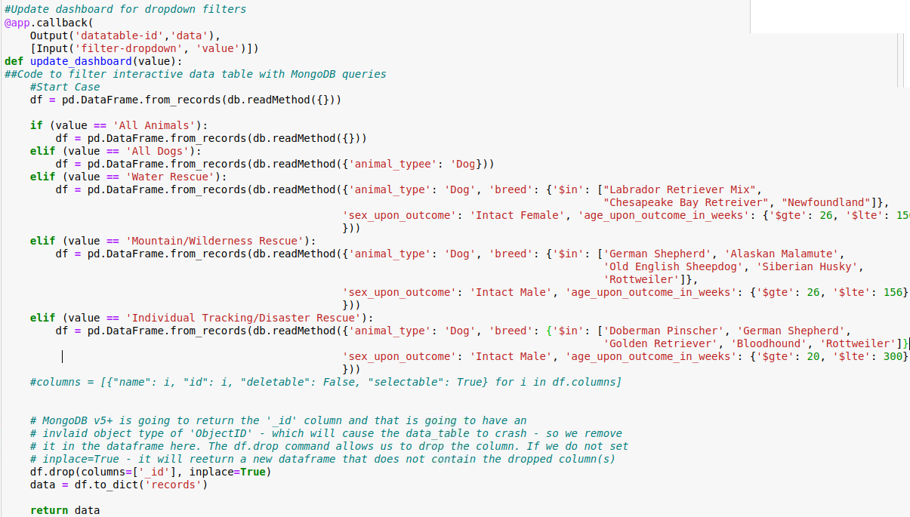

Callback for updating graphs/charts

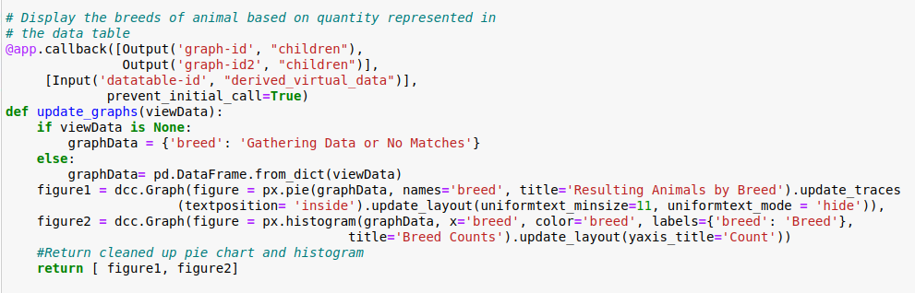

Callback to update geolocation chart (map)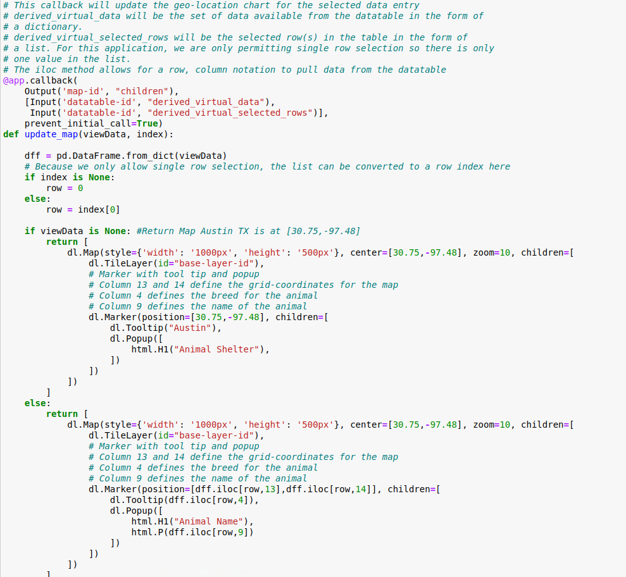

### Tests

**Crud Module Tests (Completed on prior version in week 5 – to skip to Dashboard Testing please go to page 13).**

Testing the CRUD Module is made simple with the included testing script. Launch Jupyter and run through the cells in the testing script file while observing functionality. User can then add their own tests or modify tests as needed. See screenshots below, the screenshots were done on a prior release, the CRUD filename has changed from cs340Project1 in the image below to CRUD_pythonMod in this version.

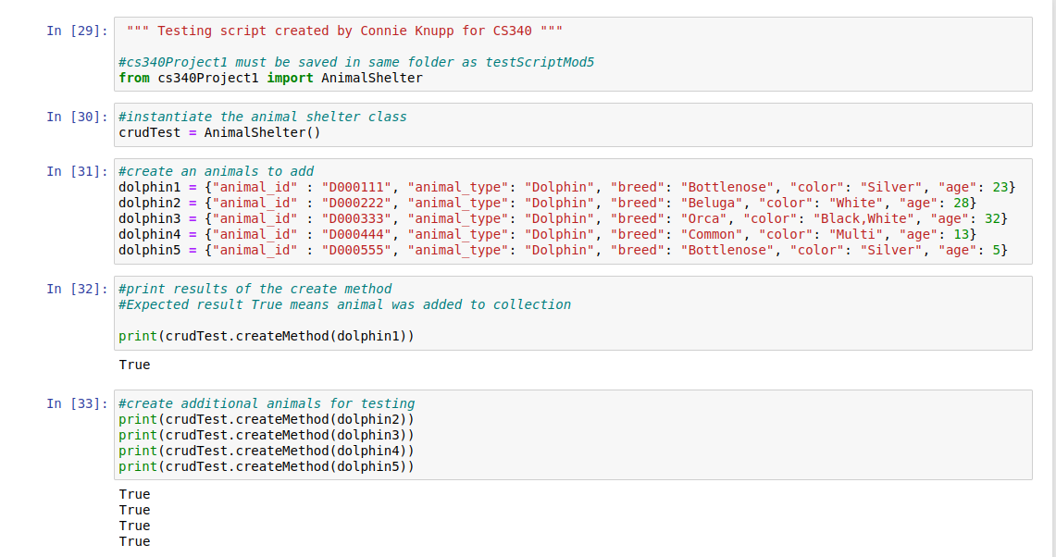

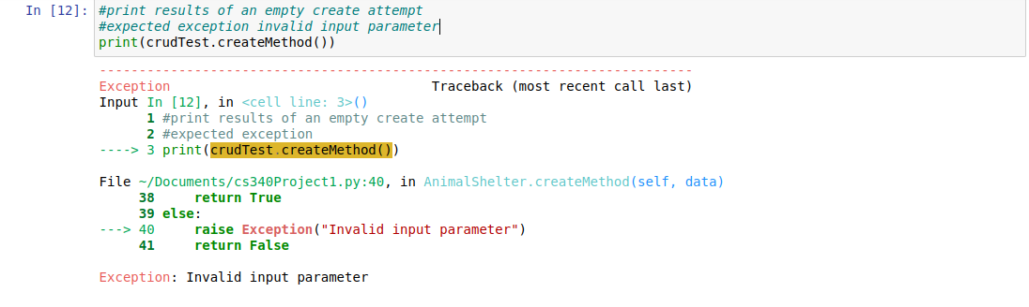

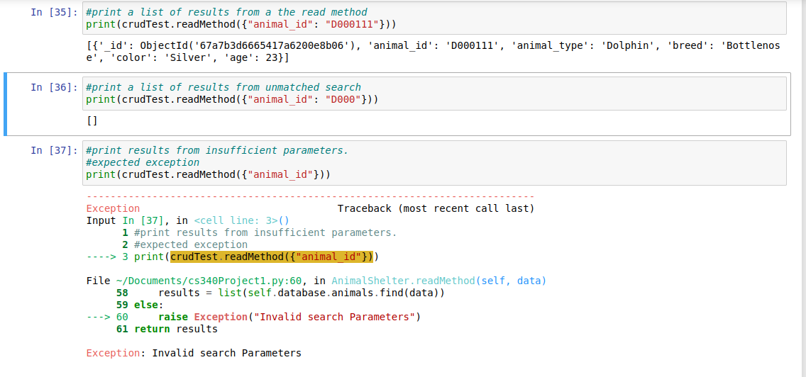

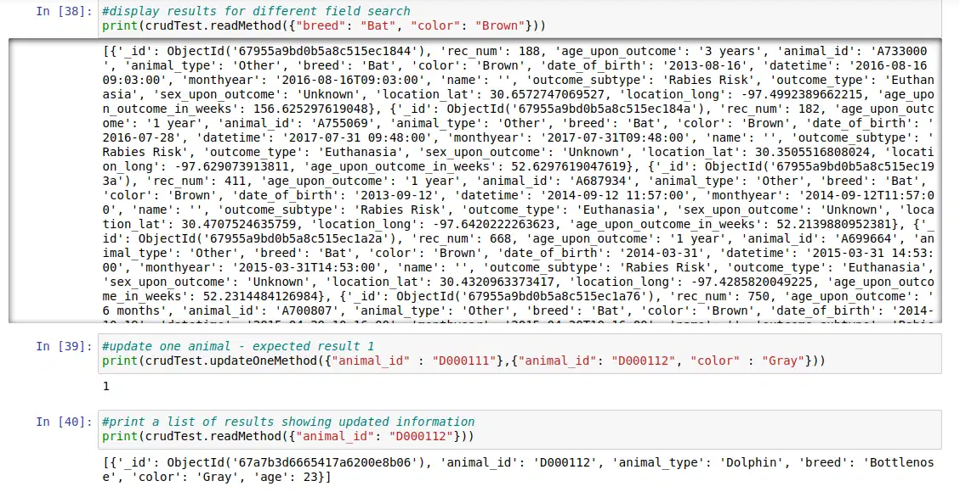

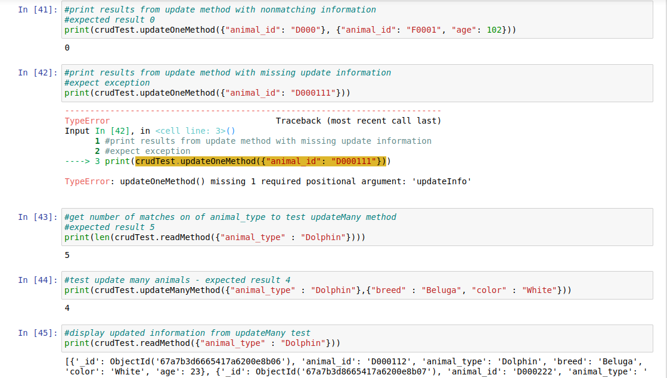

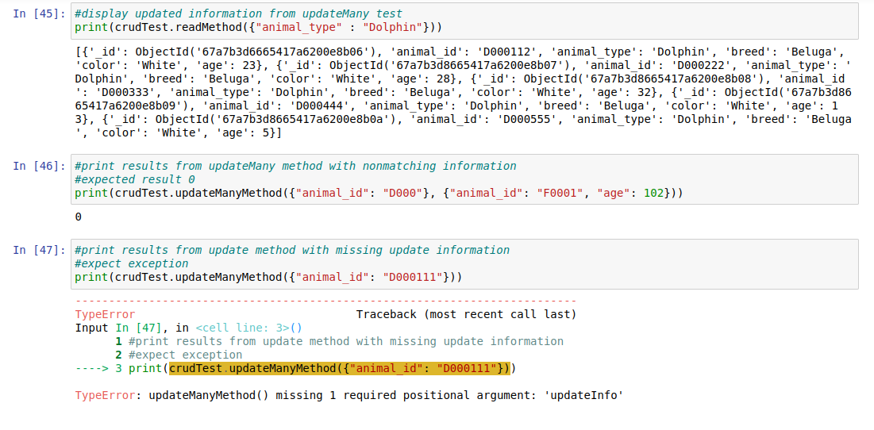

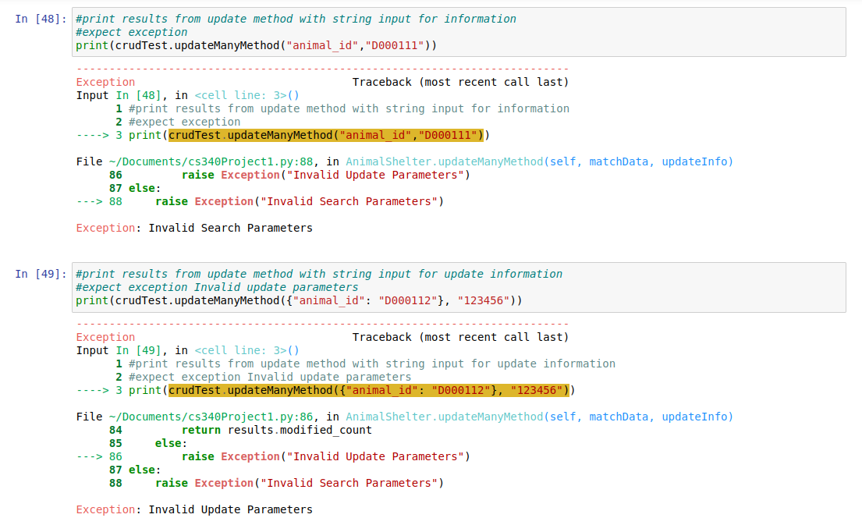

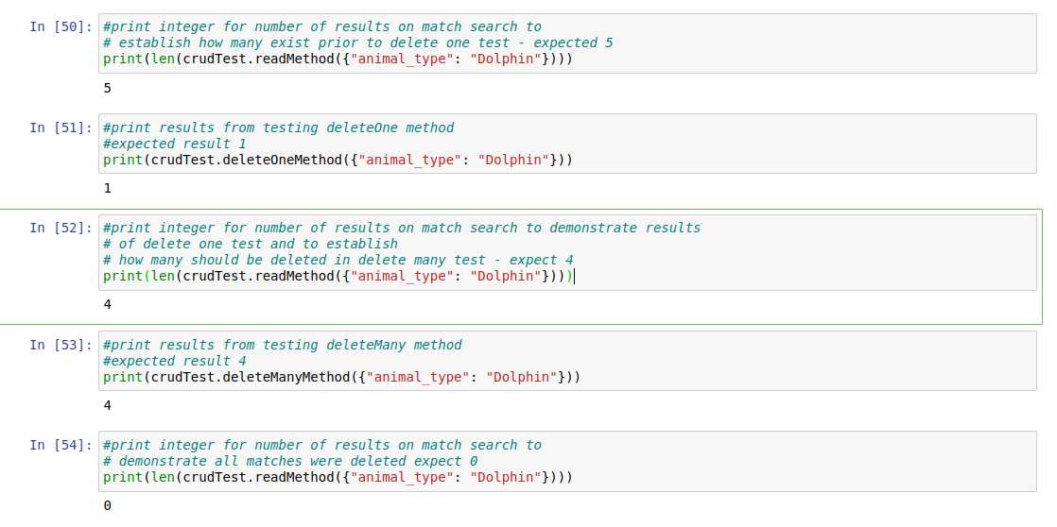

**Dashboard Tests (Current Release)**

Testing the dashboard is also straightforward. The user can open ProjectTwoDashboardCknupp and run the cell. The hyperlink for the dashboard should populate below the cell once run (see below), or the user can navigate to an internet browser and enter the URL in the address bar. 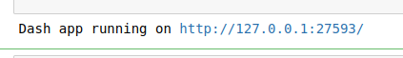

Preset filter dropdown matches the table Grazioso Salvare sent for rescue types.



Customer provided table.

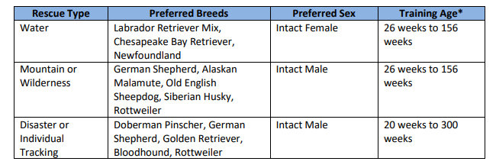

Testing filters on column ‘breed’ the text filter can be toggled to case sensitive or not. 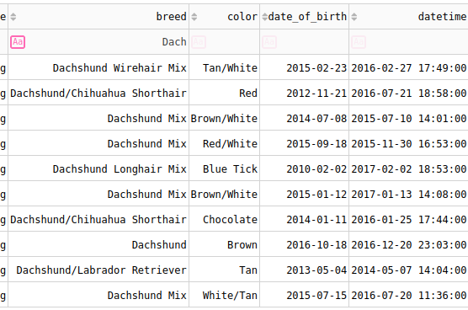

Dashboard should have the following features. 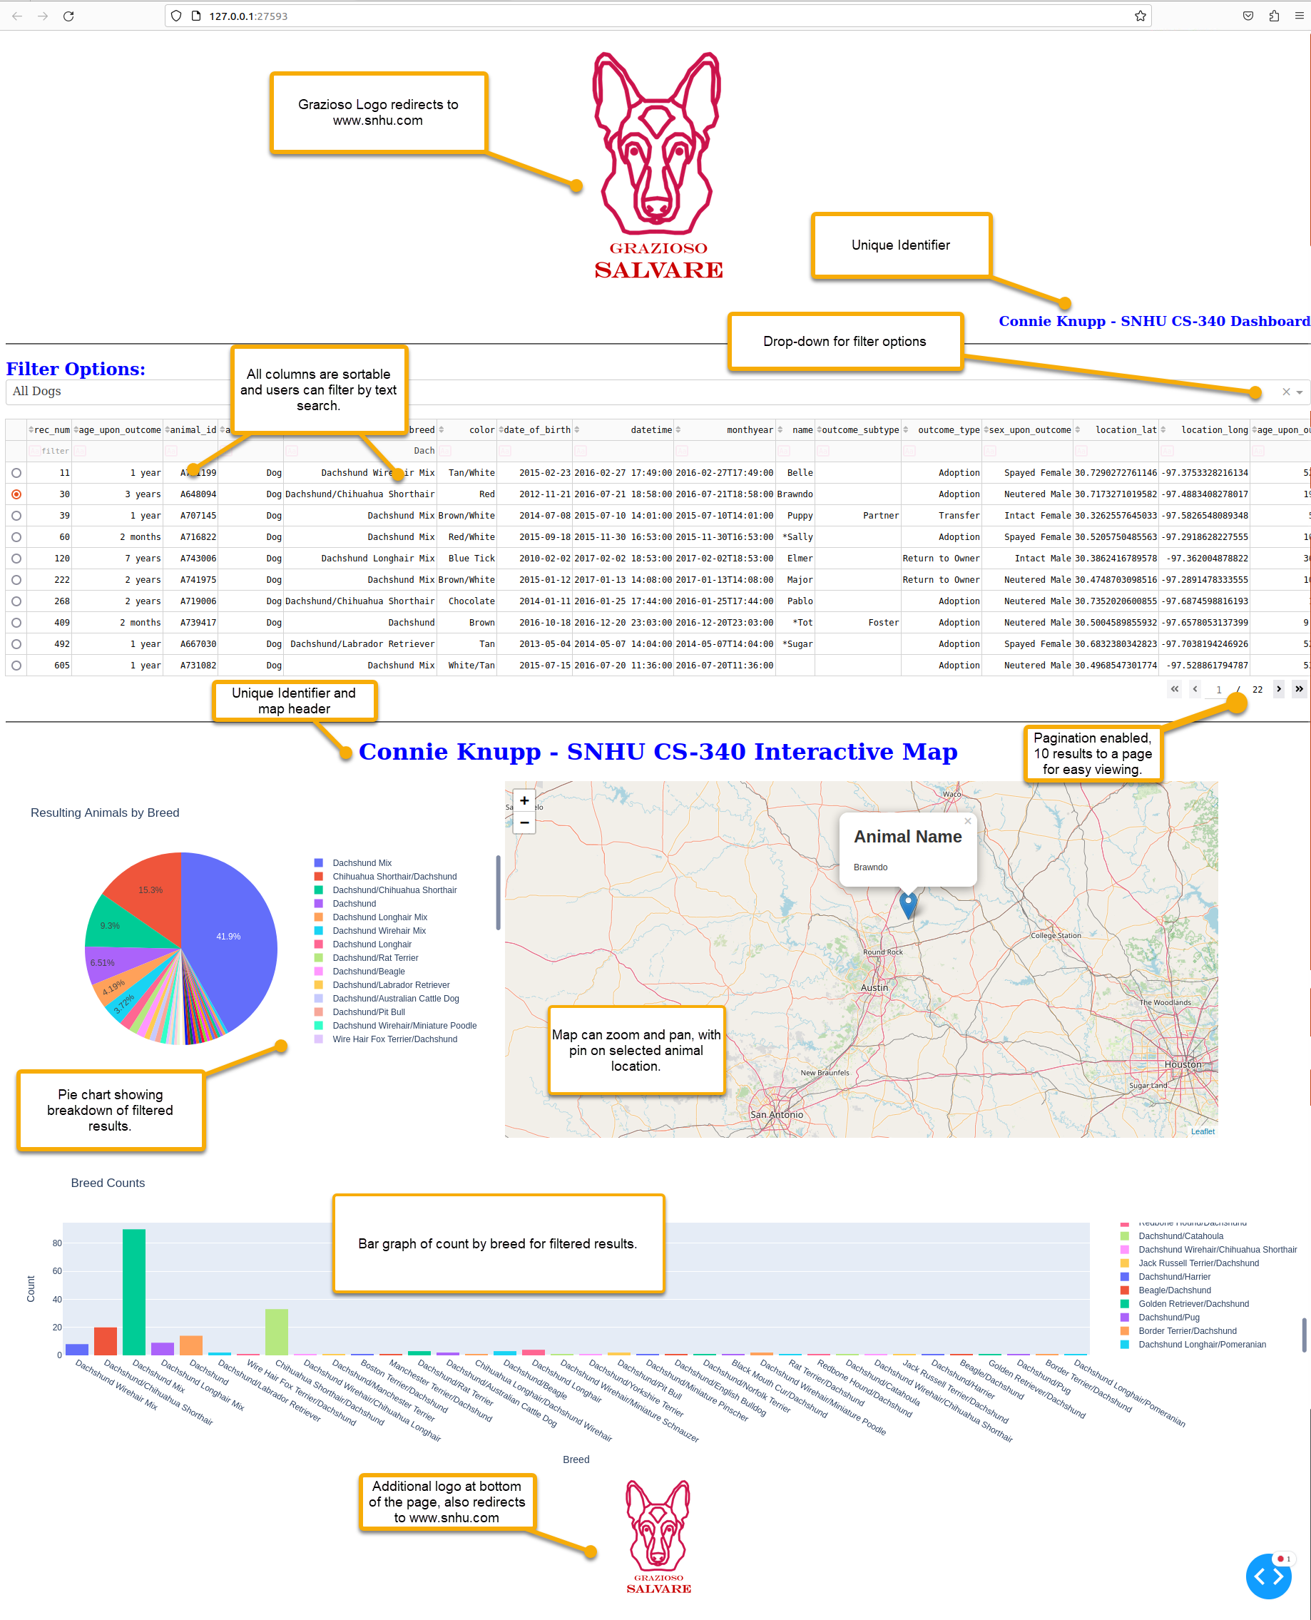

All Animals / Reset Filters Test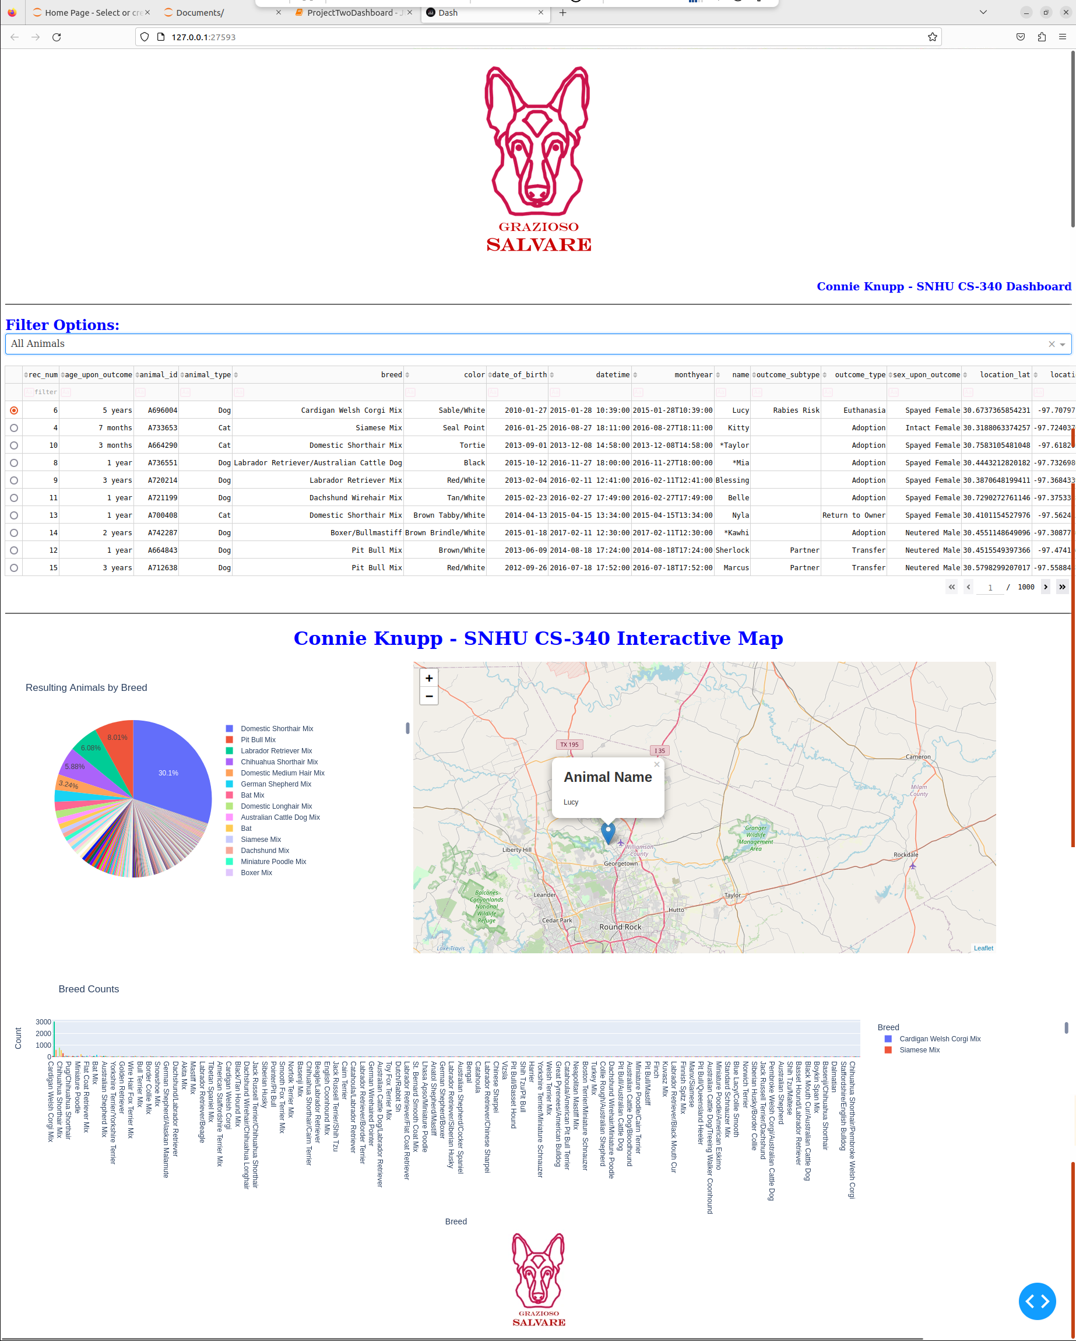

Water Rescue Filters

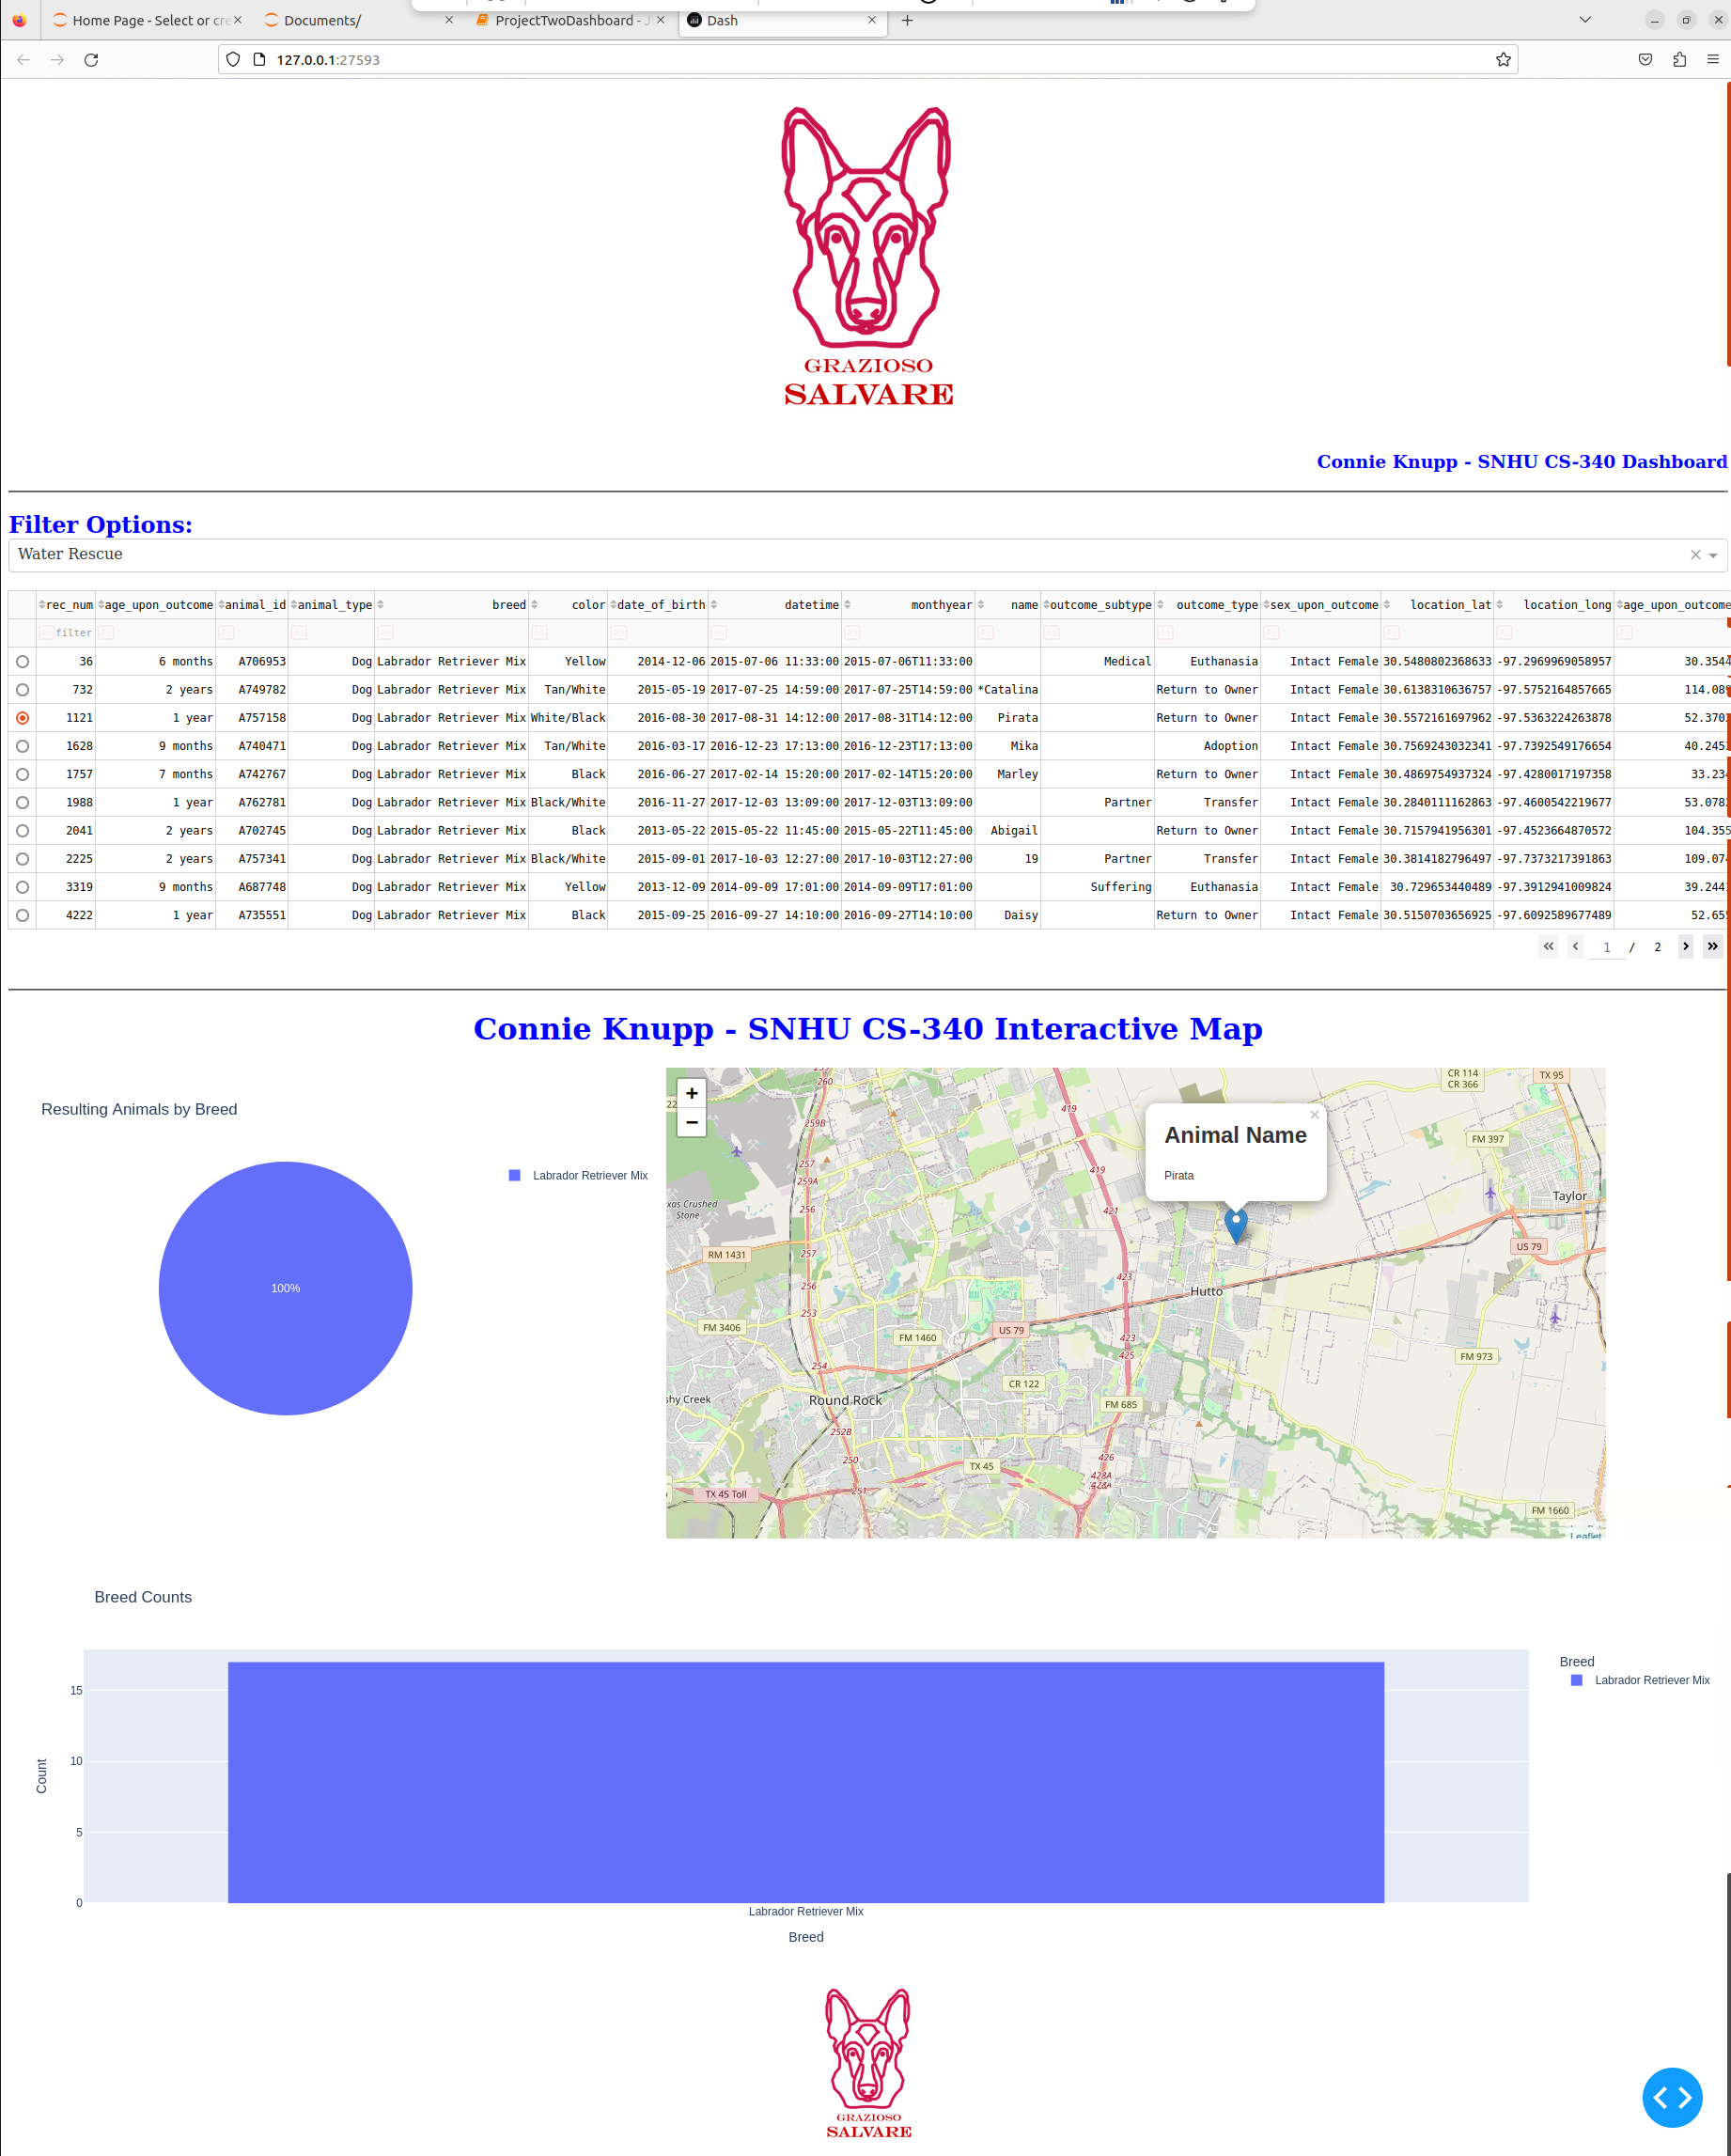

Mountain Rescue Filters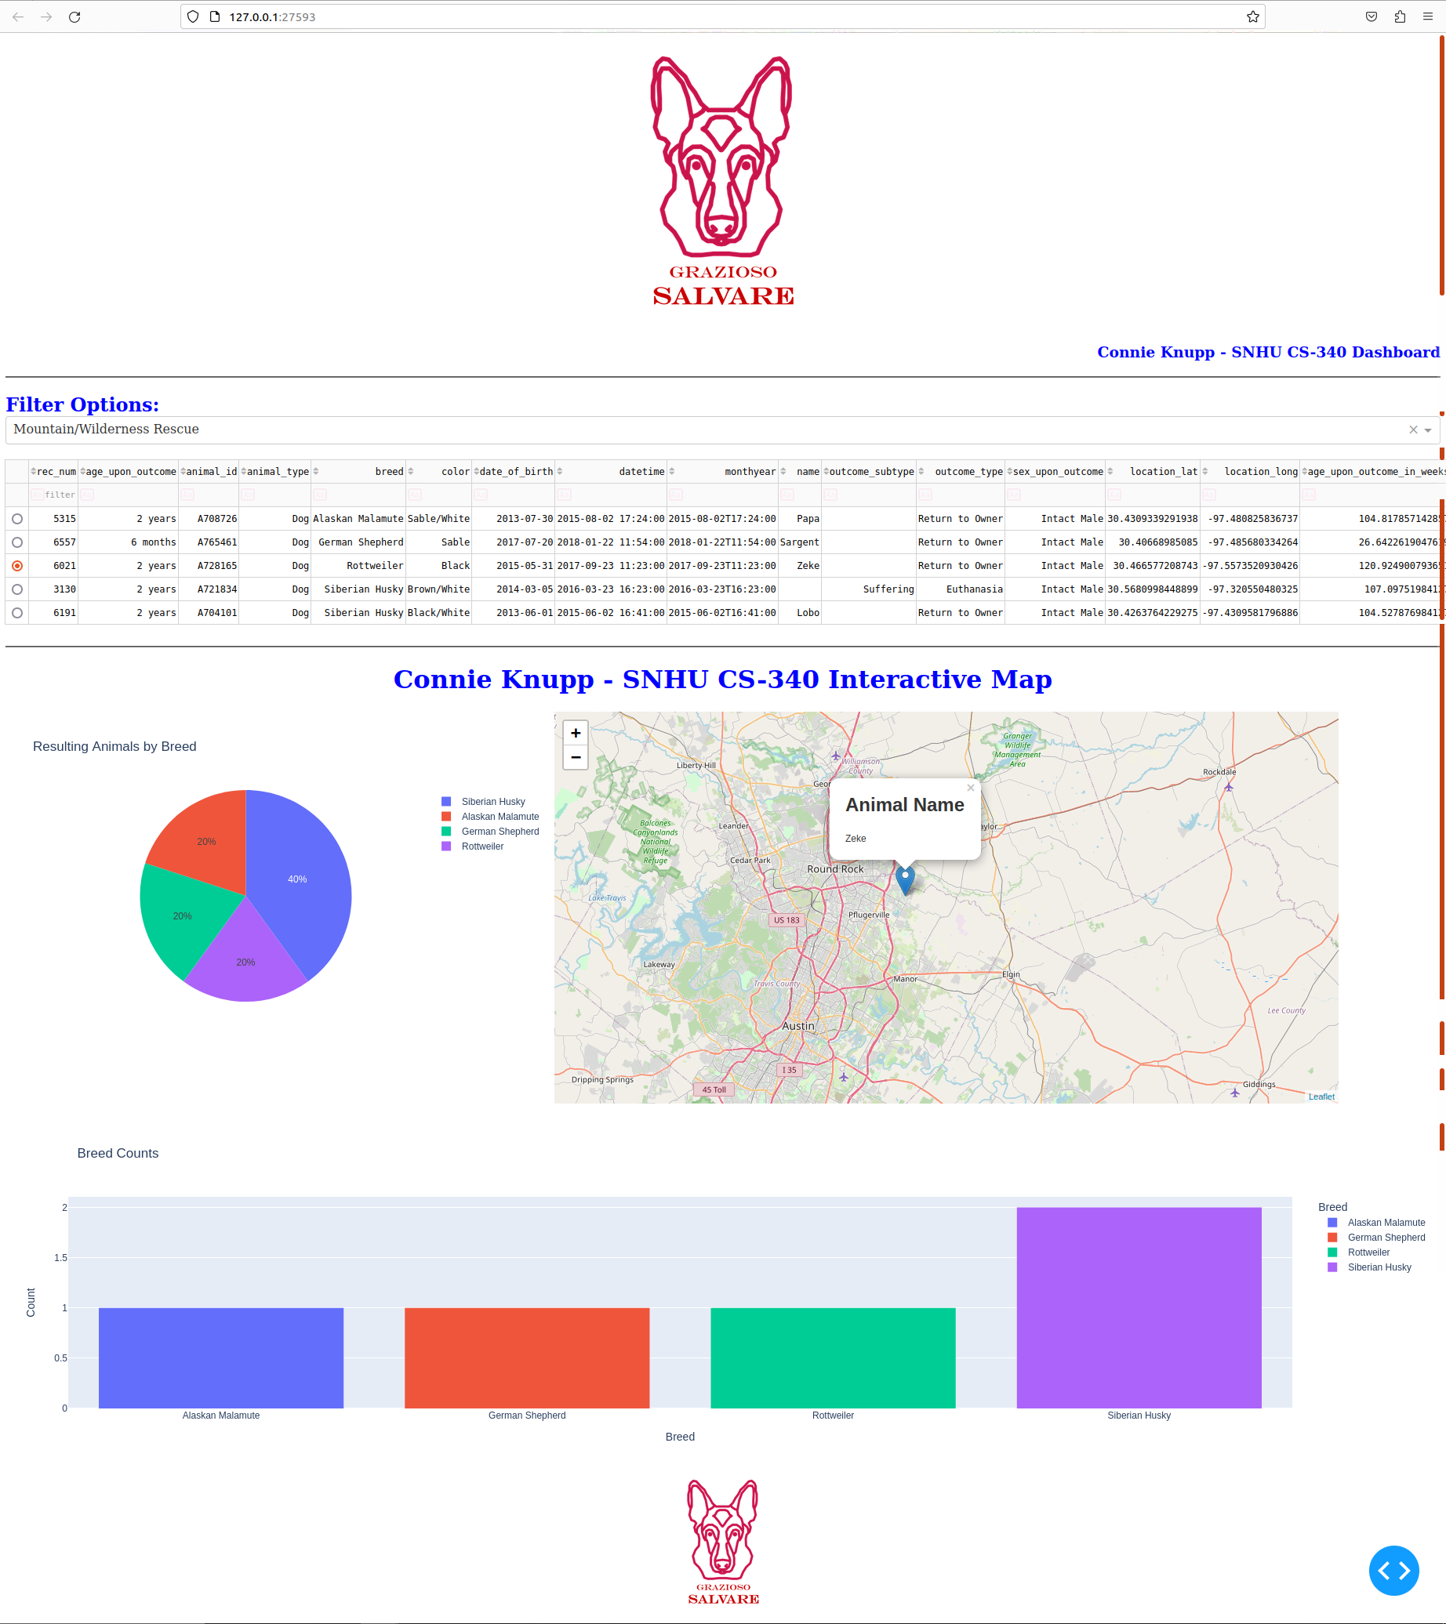

Disaster Rescue Filters

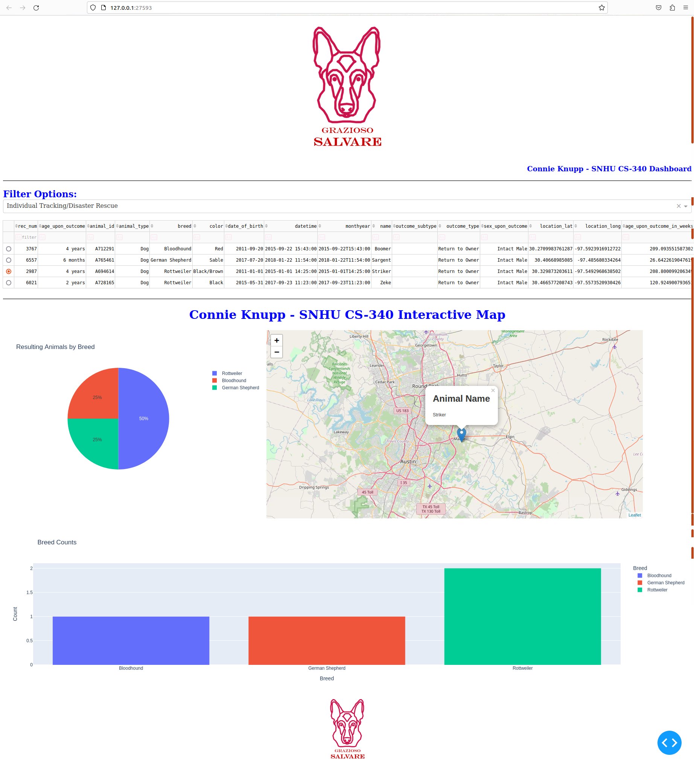

## Roadmap/Features (Optional)

Features to be added to the web-based application:

* User authentication
* May update map to display up to 10 matching animals on map depending on user feedback.

Common Issues:

1. The port included in class initialization will need to be updated to match your environment. The appropriate port can be found on the return string on terminal window when you launch the mongo shell as demonstrated below.

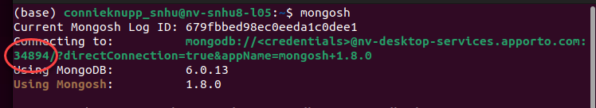

1. Execution will fail if files are not in the saved in the same folder. Please make sure the following files are all saved in the same folder.

* asset folder containing Grazioso Salvare Logo.png
* CRUD_pythonMod.py
* ProjectTwoDashboardCKnupp.ipynb
* testScriptMod5.ipynb (\*\*\***only needed if** testing CRUD functionality separately from dashboard***).

Challenges: Working within the Dash framework to resize the dynamic charts was challenging. I would have liked to enlarge the bar graph when all animals are displayed but since its size is dependent on filtered animals it would then be too large for smaller matching data sizes. I need to research more to get a better dynamic resizing solution. The second challenge I encountered was if the user filtered results to something without a match misspelling a breed for example, the map and the graph update callback would throw an error. It did not crash the application but it would fail to update the chart or map. In the future I would like them to change to a no matching results found placeholder if possible.

## Contact

Your name: Connie Knupp

Email: connie.knupp@SNHU.edu